**Interview Questions**

# Problem 1:

# Find the distance travelled by each car per day.

Suppose you have a car travelling certain distance and the data is presented as follows:

Day 1 - 50 Kms

Day 2 - 100 Kms

Day 3 - 200 Kms

Now the distance is a cumulative sum as in:

Row 2 = (Kms travelled by car on that day + Row 1 kms)

How should we create a table in the form of Kms travelled by the car on a given day and not the sum of the total distance?

**select *,**

**(cumulative_distance - lag(cumulative_distance, 1, 0)**

**over (partition by cars order by cars))**

**as distance_travelled**

**from car_travels;**

## Query Explanation:

The query calculates the distance traveled by each car on a specific day using cumulative distance data from the car_travels table.

## Query Breakdown:

**select *: Selects all columns from the car_travels table.**

(cumulative_distance - lag(cumulative_distance, 1, 0) over (partition by cars order by cars)):

**lag(cumulative_distance, 1, 0):**

Retrieves the cumulative distance of the previous row for the same car (partition by cars).

If no previous row exists (e.g., Day 1), it defaults to 0 (third parameter).

**cumulative_distance - lag(...):**

Subtracts the previous day's cumulative distance from the current day's cumulative distance to calculate the distance travelled on that specific day.

**as distance_travelled:**

Renames the result of the calculation to distance_travelled.

**Window Function:**

**over (partition by cars order by cars):**

Divides the data by each car (partition by cars), ensuring calculations are performed within the scope of a single car.

Orders the rows for each car to process the cumulative distances in sequence.

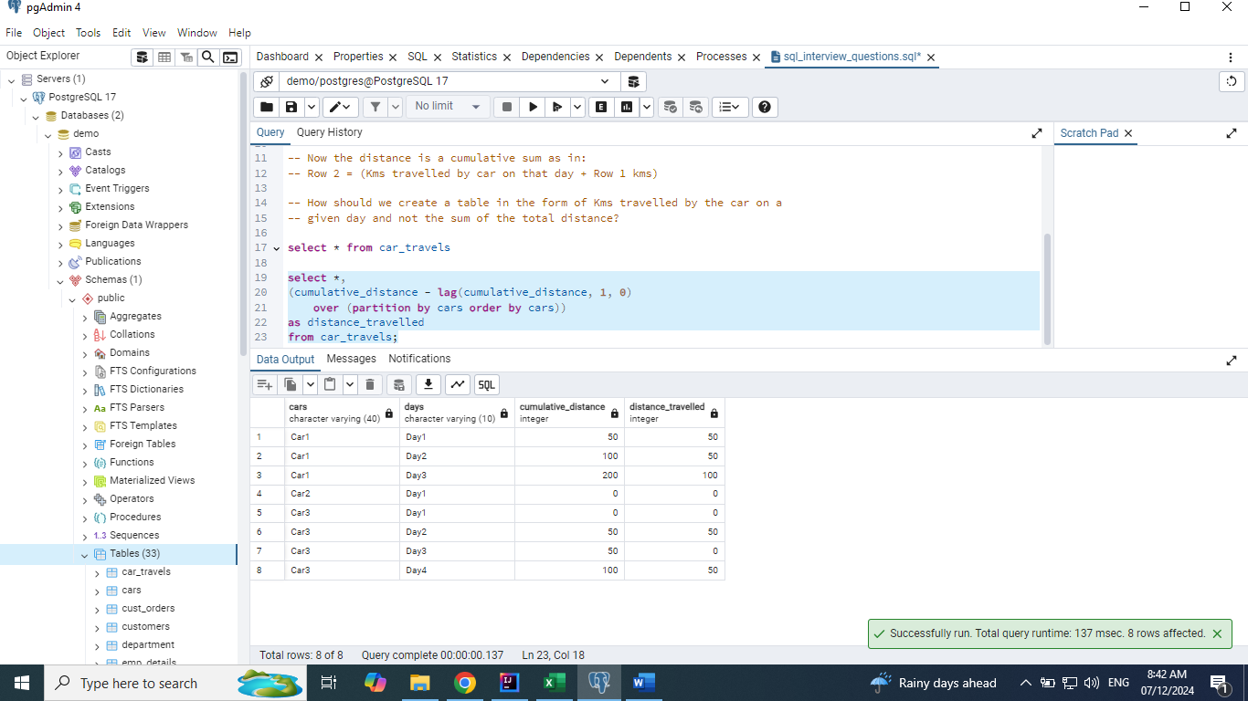

# Problem 2:

# Convert the Row level data to Column level data. Also, Combine the data of pair of rows using comma.

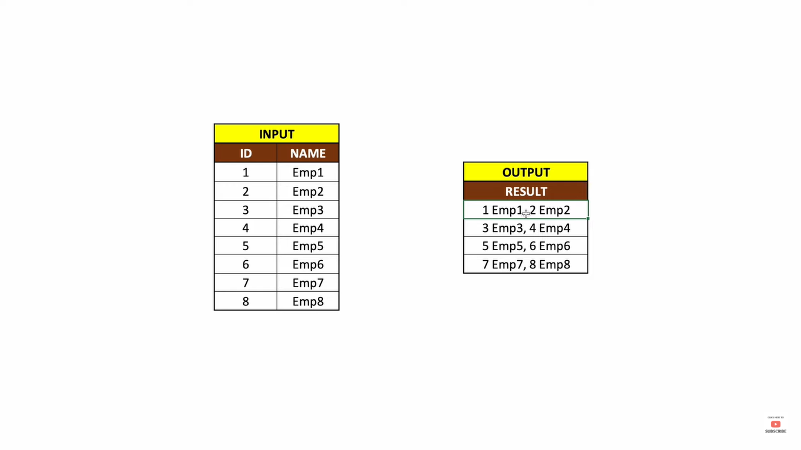

**select *,**

**ntile(4) over(order by id) as buckets**

**from emp_input;**

**select concat(id,' ', name) as name,**

**ntile(4) over(order by id) as buckets**

**from emp_input;**

**with cte as**

**(select concat(id,' ', name) as name,**

**ntile(4) over(order by id) as buckets**

**from emp_input)**

**select string_agg(name, ', ') as final_result**

**from cte**

**group by buckets**

**order by 1;**

## Query Explanation:

The query divides employees into 4 equal-sized groups (buckets) based on their id and then concatenates their id and name into a comma-separated string for each bucket.

## Query Breakdown:

**Step 1: Common Table Expression (CTE)**

with cte as (

select

concat(id, ' ', name) as name,

ntile(4) over (order by id) as buckets

from emp_input

)

**concat(id, ' ', name) as name:**

Combines the id and name of each employee into a single string, formatted as "id name".

For example: 1 Emp1, 2 Emp2, etc.

**ntile(4) over (order by id):**

Divides the employees into 4 groups (buckets).

The ntile function evenly distributes rows across the specified number of groups.

Groups are formed based on the id in ascending order.

**Step 2: Aggregating and Grouping**

select

string_agg(name, ', ') as final_result

from cte

group by buckets

order by 1;

string_agg(name, ', '):

Aggregates all name values in each bucket into a single comma-separated string.

For example: "1 Emp1, 2 Emp2" for the first bucket.

group by buckets:

Groups rows by their assigned bucket, ensuring that string_agg works within each bucket.

order by 1:

Orders the final results by the aggregated string.

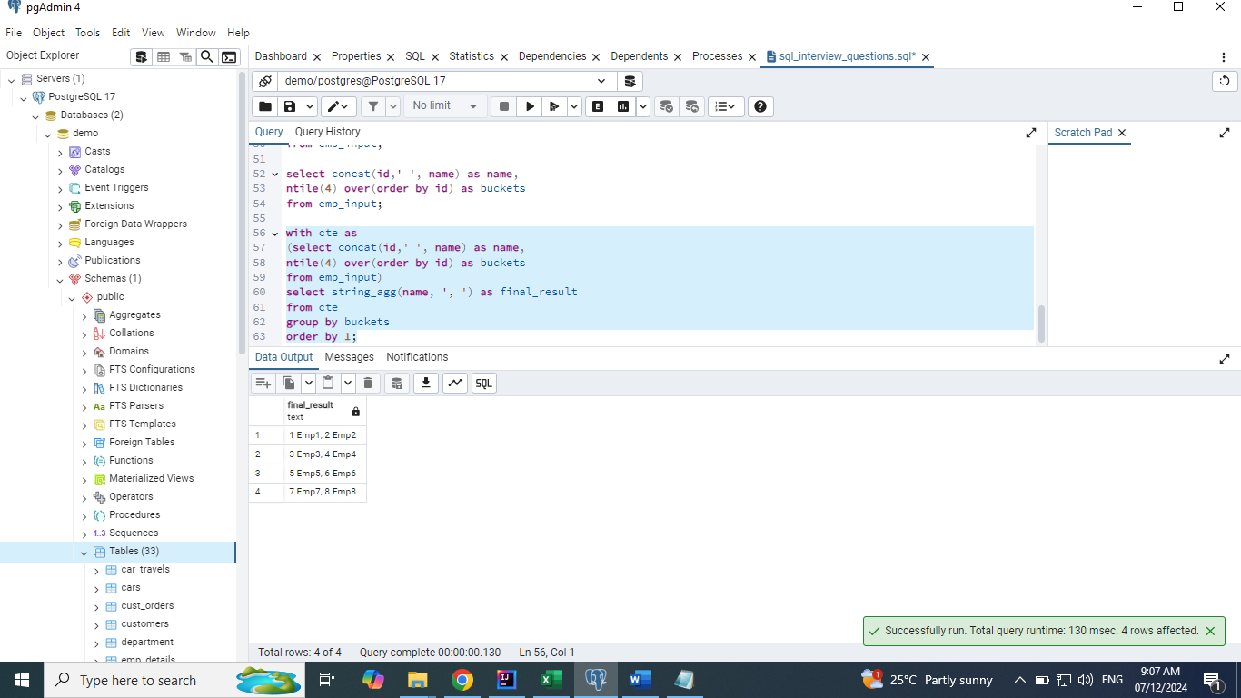

# Problem 3:

# Write a solution to report the type of each node in the tree. Return the result table in any order.

Table: Tree

+-------------+------+

| Column Name | Type |

+-------------+------+

| id | int |

| p_id | int |

+-------------+------+

id is the column with unique values for this table.

Each row of this table contains information about the id of a node and the id of its parent node in a tree.

The given structure is always a valid tree.

Each node in the tree can be one of three types:

* **"Leaf"**: if the node is a leaf node.
* **"Root"**: if the node is the root of the tree.
* **"Inner"**: If the node is neither a leaf node nor a root node.

Write a solution to report the type of each node in the tree.

Return the result table in **any order**.

The result format is in the following example.

**Example 1:**

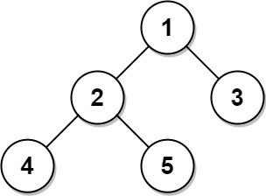

**Input:**

Tree table:

+----+------+

| id | p_id |

+----+------+

| 1 | null |

| 2 | 1 |

| 3 | 1 |

| 4 | 2 |

| 5 | 2 |

+----+------+

**Output:**

+----+-------+

| id | type |

+----+-------+

| 1 | Root |

| 2 | Inner |

| 3 | Leaf |

| 4 | Leaf |

| 5 | Leaf |

+----+-------+

**Explanation:**

Node 1 is the root node because its parent node is null and it has child nodes 2 and 3.

Node 2 is an inner node because it has parent node 1 and child node 4 and 5.

Nodes 3, 4, and 5 are leaf nodes because they have parent nodes and they do not have child nodes.

**Example 2:**



**Input:**

Tree table:

+----+------+

| id | p_id |

+----+------+

| 1 | null |

+----+------+

**Output:**

+----+-------+

| id | type |

+----+-------+

| 1 | Root |

+----+-------+

**Explanation:** If there is only one node on the tree, you only need to output its root attributes.

## Query Explanation:

This query determines the type of each node in a tree structure based on its relationships with parent and child nodes. The type of each node is classified as Root, Inner, or Leaf.

## Query Breakdown:

**Basic Selection:**

select *

from tree;

Selects all columns (id, p_id) from the tree table.

**Type Classification with CASE:**

case

when p_id is null then 'Root'

when p_id is not null and id in (select distinct p_id from tree) then 'Inner'

else 'Leaf'

end as type

**Condition 1:**

**when p_id is null then 'Root'**

A node is classified as Root if its p_id (parent ID) is null. This indicates the node has no parent and is the top-most node in the tree.

**Condition 2:**

**when p_id is not null and id in (select distinct p_id from tree) then 'Inner'**

A node is classified as Inner if:

It has a parent (p_id is not null).

It is a parent of other nodes (id in (select distinct p_id from tree)). This checks whether the id appears in the p_id column of any row in the tree table.

**Condition 3:**

else 'Leaf'

A node is classified as Leaf if:

It has a parent (p_id is not null).

It is not a parent of any other node. In this case, the id does not appear in the p_id column of the tree table.

**select *,**

**case**

**when p_id is null then 'Root'**

**when p_id is not null and id in (select distinct p_id from tree) then 'Inner'**

**else 'Leaf'**

**end as type**

**from tree;**

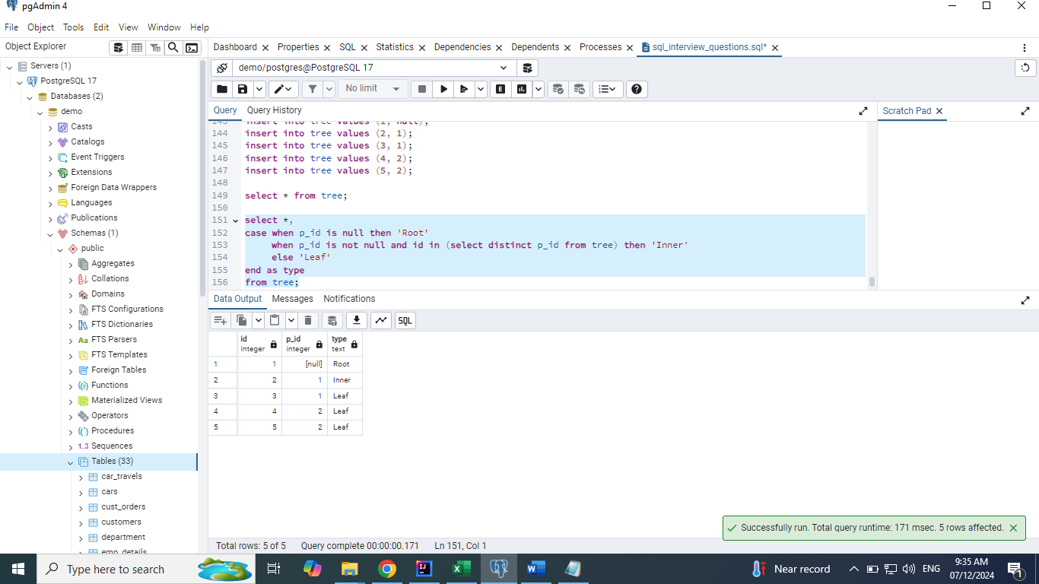

# Problem 4:

# Find the most modified file extension for the day

A DB contains a list of filenames including their extensions and the dates they were last modified. For each date that a modification was made, return the date, the extension(s) of the files that were modified the most, and the number of files modified that date. If more than one file extension ties for the most modifications, return them as a comma delimited list in reverse order.

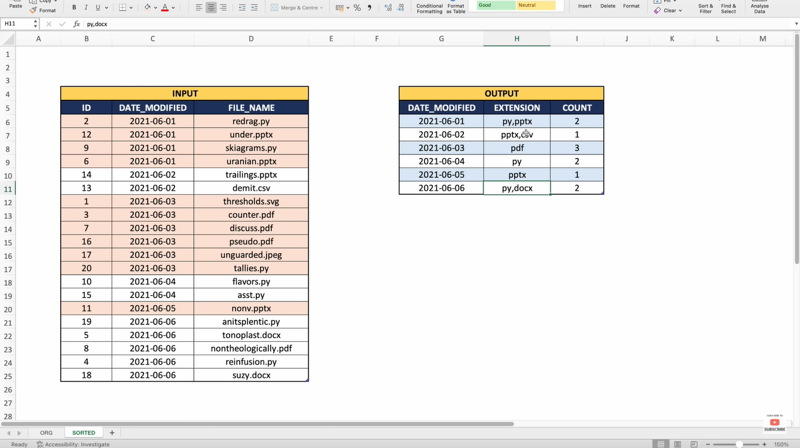

Problem Breakdown

Fetch the file extension

select * , position('.' in file_name)

from files;

select date_modified, substring(file_name, (position('.' in file_name)+1)) as file_ext

from files;

For each day, how many times each file extension was modified

select date_modified, substring(file_name, (position('.' in file_name)+1)) as file_ext, count(1) as cnt

from files

group by date_modified, file_ext

order by 1;

For each day, fetch the most modified file extension from #2

with cte as

(select date_modified, substring(file_name, (position('.' in file_name)+1)) as file_ext, count(1) as cnt

from files

group by date_modified, file_ext

order by 1)

select *

from cte c1

where cnt = (select max(cnt) from cte c2

where c2.date_modified = c1.date_modified);

If there is tie, then concatenate the multiple file extension

## Query Explanation:

The given query identifies the file extensions that were most frequently modified on each date from a database of files. It returns the following for each modification date:

1. The **modification date**.
2. The **file extension(s)** with the highest count of modifications for that date (comma-separated in reverse alphabetical order if there's a tie).
3. The **number of files modified** for the most frequent file extension(s) on that date.

## Query Breakdown:

**Extract File Extension and Count by Date:**

A Common Table Expression (cte) is created.

For each date_modified, the query extracts the file extension using substring(file_name, (position('.' in file_name) + 1)).

It counts the number of files modified for each date_modified and file_ext combination.

The result is grouped by date_modified and file_ext, and ordered by the modification date

**Find Extensions with Maximum Modifications Per Date:**

The main query iterates through each row of the cte.

It compares the cnt of each file extension with the maximum cnt for that date_modified using a subquery.

If the cnt equals the maximum, the extension is considered one of the most modified for that date.

**Aggregate Extensions in Reverse Alphabetical Order:**

For each date_modified, extensions meeting the maximum count criteria are concatenated into a single string using string_agg with ORDER BY file_ext DESC.

**Final Output:**

The query groups the results by date_modified.

**It selects:**

date_modified.

A comma-separated list of extensions in reverse alphabetical order (extension).

The maximum count of modified files for that date (count).

**with cte as**

**(select date_modified, substring(file_name, (position('.' in file_name)+1)) as file_ext, count(1) as cnt**

**from files**

**group by date_modified, file_ext**

**order by 1)**

**select date_modified,**

**string_agg(file_ext, ', ' order by file_ext desc) as extension,**

**max(cnt) as count**

**from cte c1**

**where cnt = (select max(cnt) from cte c2**

**where c2.date_modified = c1.date_modified)**

**group by date_modified;**

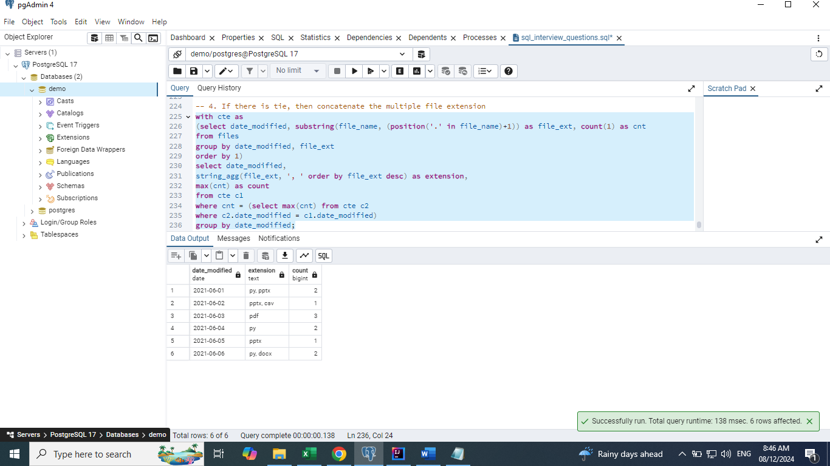

# Problem 5:

Find the hierarchy of employees

For each employee, showcase all the employee's working under them (including themselves)

Such that, when the child tree expands i.e., every new employee should be dynamically

assigned to their managers till the top-level hierarchy.

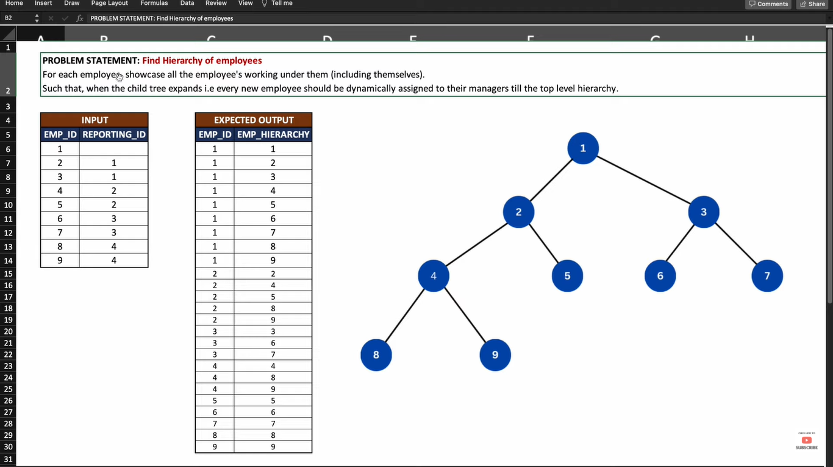

## Recursive SQL syntax

**with recursive cte as**

**(base query**

**union all**

**recursive part of the query**

**termination / exit condition)**

**select \***

**from cte;**

## Query Explanation:

The query generates the **hierarchy of employees** from a table, emp_hierarchy, where each row defines an employee and their manager (or reporting_id). For each employee, it lists:

* The employee themselves.
* All employees working under them, either directly or indirectly, forming a tree-like structure.

## Query Breakdown:

**1. Recursive Common Table Expression (CTE):**

The query uses a WITH RECURSIVE clause to define a CTE, called cte, to compute the hierarchy dynamically.

with recursive cte as

(

select emp_id, emp_id as employee_hierarchy

from emp_hierarchy

union all

select cte.emp_id, eh.emp_id as employee_hierarchy

from cte

join emp_hierarchy eh on cte.employee_hierarchy = eh.reporting_id

)

**Base Case:**

select emp_id, emp_id as employee_hierarchy

from emp_hierarchy

Starts with the base row for each emp_id.

Here, employee_hierarchy is initialized to the emp_id itself, meaning each employee is their own manager.

**Recursive Step:**

select cte.emp_id, eh.emp_id as employee_hierarchy

from cte

join emp_hierarchy eh on cte.employee_hierarchy = eh.reporting_id

The recursive step finds all employees who report to someone already in the hierarchy.

It iterates through the hierarchy to add employees working under the emp_id in the CTE.

**2. Final Output:**

The select statement retrieves the hierarchy:

select *

from cte

order by emp_id, employee_hierarchy;

For each emp_id, it lists their entire hierarchy, including themselves, sorted by emp_id and employee_hierarchy.

**with recursive cte as**

**(select emp_id, emp_id as employee_hierarchy**

**from emp_hierarchy**

**union all**

**select cte.emp_id, eh.emp_id as employee_hierarchy**

**from cte**

**join emp_hierarchy eh on cte.employee_hierarchy = eh.reporting_id)**

**select \***

**from cte**

**order by emp_id, employee_hierarchy;**

**1st Iteration**

**select emp_id, emp_id as employee_hierarchy**

**from emp_hierarchy where emp_id = 1;**

**2nd Iteration**

**select cte.emp_id, eh.emp_id as employee_hierarchy**

**from (select emp_id, emp_id as employee_hierarchy**

**from emp_hierarchy where emp_id = 1) cte**

**join emp_hierarchy eh on cte.employee_hierarchy = eh.reporting_id;**

**3rd Iteration**

**select cte.emp_id, eh.emp_id as employee_hierarchy**

**from (select cte.emp_id, eh.emp_id as employee_hierarchy**

**from (select emp_id, emp_id as employee_hierarchy**

**from emp_hierarchy where emp_id = 1) cte**

**join emp_hierarchy eh on cte.emp_id = eh.reporting_id)cte**

**join emp_hierarchy eh on cte.employee_hierarchy = eh.reporting_id;**

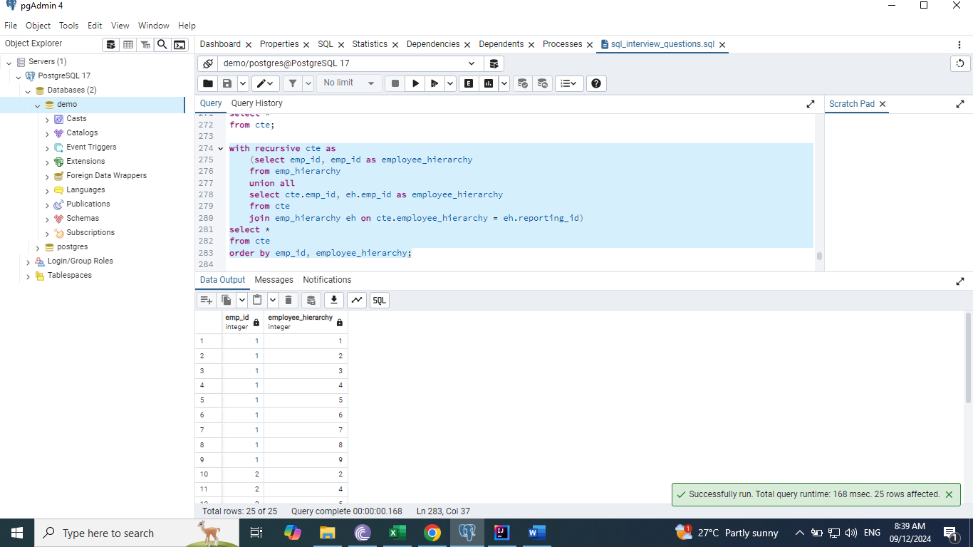

# Problem 6:

Given is a list of arbitrary values. They can either be comma separated values in a single row column or they could be values spread across multiple rows. Write an SQL Query to group these arbitrary values as per the expected output.

**Step by Step approach**

**Convert the column level data to row level data**

select unnest(val) from arbitrary_values;

**Adding unique identifier with ordinality**

select x.*

from arbitrary_values

cross join unnest(val) with ordinality x(val, index);

## Query Explanation:

This SQL query transforms a single-column array of values into grouped rows where each group size grows incrementally. Here's a step-by-step explanation:

## Query Breakdown:

**Step 1: Explode the Array Column**

The array val is expanded into rows using the unnest function:

**SELECT unnest(val) FROM arbitrary_values;**

This converts an array like "{a1,a2,a3,...}" into a single column of values (a1, a2, etc.) in individual rows.

**Step 2: Add Ordinality**

To maintain the original order and allow indexing, unnest is combined with the WITH ORDINALITY option:

**SELECT x.\***

**FROM arbitrary_values**

**CROSS JOIN UNNEST(val) WITH ORDINALITY x(val, index);**

val: The individual values from the array.

index: The position of the value in the original array.

This gives rows like:

val index

a1 1

a2 2

a3 3

... ...

This result is stored in the cte_values Common Table Expression (CTE).

**Step 3: Create Recursive Groups**

Using a Recursive CTE, the query builds groups with sizes that increase incrementally. Here's the breakdown:

**3.1. Base Case**

The first row (index = 1) initializes the recursion:

**SELECT *, 1 AS iterator, MAX(index) OVER() AS max_index**

**FROM cte_values**

**WHERE index = 1;**

iterator = 1: Group number starts at 1.

max_index: Stores the highest index value to track group boundaries.

**3.2. Recursive Case**

Each recursive step processes the next set of rows by expanding the group size by one:

**SELECT cv.*, (iterator + 1), MAX(cv.index) OVER() AS max_index**

**FROM cte**

**JOIN cte_values cv**

**ON cv.index BETWEEN max_index + 1 AND max_index + 1 + iterator;**

**cv: Refers to rows in cte_values.**

iterator + 1: Advances to the next group.

index BETWEEN max_index + 1 AND max_index + 1 + iterator: Picks the next set of rows for the current group.

**Step 4: Aggregate Values into Groups**

Once grouped, the query aggregates the values in each group into a comma-separated string using string_agg:

**SELECT iterator AS grp, STRING_AGG(val, ' , ') AS values**

**FROM cte**

**GROUP BY iterator**

**ORDER BY iterator;**

grp: The group number (from iterator).

values: The aggregated string of values in each group.

**Final Query**

**with recursive cte as**

**(select *, 1 as iterator, max(index) over() as max_index**

**from cte_values where index = 1**

**union**

**select cv.*, (iterator+1), max(cv.index) over() as max_index**

**from cte**

**join cte_values cv on cv.index between max_index+1 and max_index+1+iterator**

**),**

**cte_values as**

**(select x.\***

**from arbitrary_values**

**cross join unnest(val) with ordinality x(val, index))**

**select iterator as grp, string_agg(val, ' , ') as values**

**from cte**

**group by iterator**

**order by iterator;**

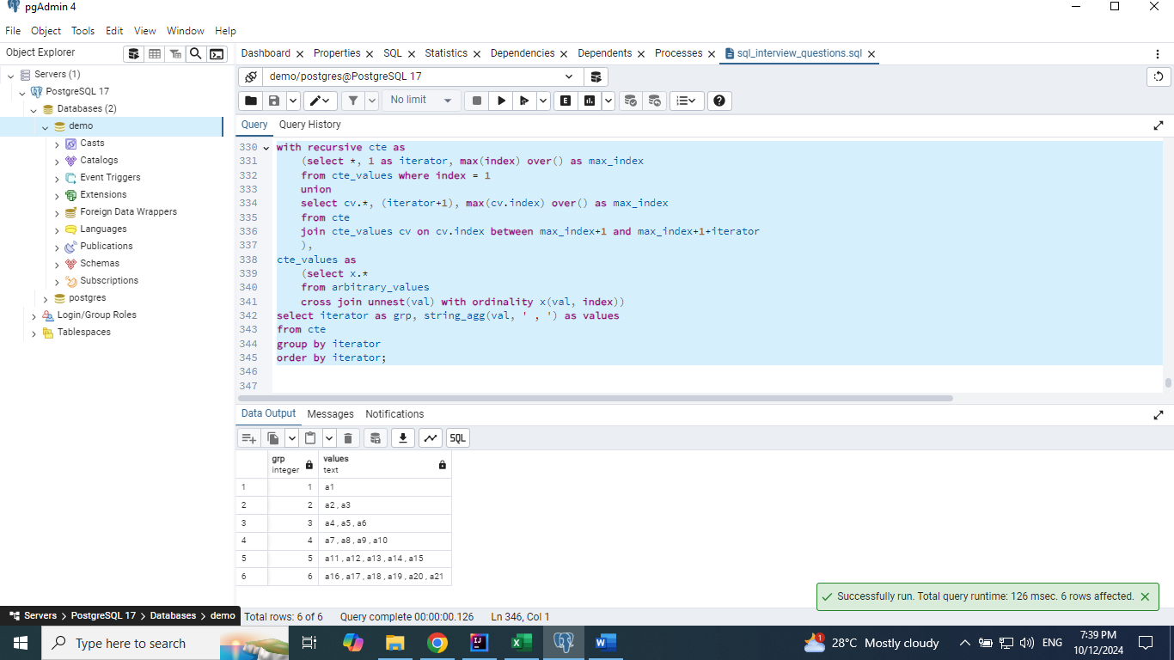

# Problem 7:

## Type1: SQL Query to fetch "N" consecutive records when temperature is below 0.

**Fetch the temperature below 0.**

select * from weather where temperature < 0;

**Add a unique row number to the data**

select *, row_number() over(order by id) as rn

from weather

where temperature < 0;

**Logic to group the data**

select *, row_number() over(order by id) as rn,

(id - row_number() over(order by id)) as difference

from weather

where temperature < 0;

## Query Explanation:

The query identifies consecutive groups of records from the weather table where the temperature is less than 0 and extracts groups of exactly 3 records.

## Query Breakdown:

**The WITH clause, also known as a Common Table Expression (CTE), is used in SQL to create temporary, named result sets that can be referenced within the main query. It helps make SQL queries more readable and modular, especially when dealing with complex logic or when a subquery is used multiple times.**

**CTE t1:**

Purpose: Add additional columns to analyze the consecutive records.

Columns added:

rn: Row number of the record ordered by id.

difference: A computed value (id - row_number() over(order by id)) that groups records with consecutive id values. This is because consecutive rows in a sequence will have the same difference.

**CTE t2:**

Purpose: Count the number of records in each group (grouped by difference).

Columns added:

no_of_records: Total number of records in the group with the same difference.

This is achieved by using a count(*) over(partition by difference).

**Final Query:**

Filters the rows to include only those groups where no_of_records = 3.

Selects the id, city, temperature, and day columns for these rows.

**Final query using with clause**

**with t1 as**

**(select *, row_number() over(order by id) as rn,**

**id - (row_number() over(order by id)) as difference**

**from weather**

**where temperature < 0),**

**t2 as**

**(select *, count(*) over(partition by difference) as no_of_records**

**from t1)**

**select id, city, temperature, day**

**from t2**

**where no_of_records = 3;**

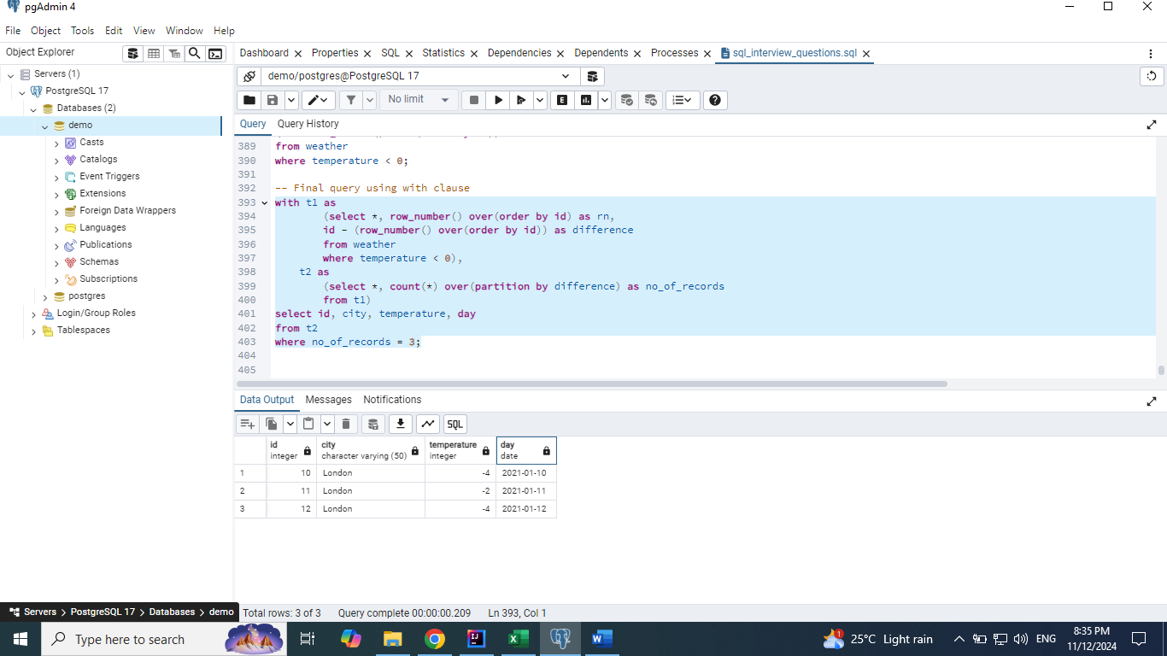

## Type 2: SQL Query to fetch "N" consecutive records when temperature is below 0 and also table doesn't have id column.

**with w as**

**(select *, row_number() over() as id**

**from vw_weather),**

**t1 as**

**(select *, row_number() over(order by id) as rn,**

**id - (row_number() over(order by id)) as difference**

**from w**

**where temperature < 0),**

**t2 as**

**(select *, count(*) over(partition by difference) as no_of_records**

**from t1)**

**select id, city, temperature**

**from t2**

**where no_of_records = 3;**

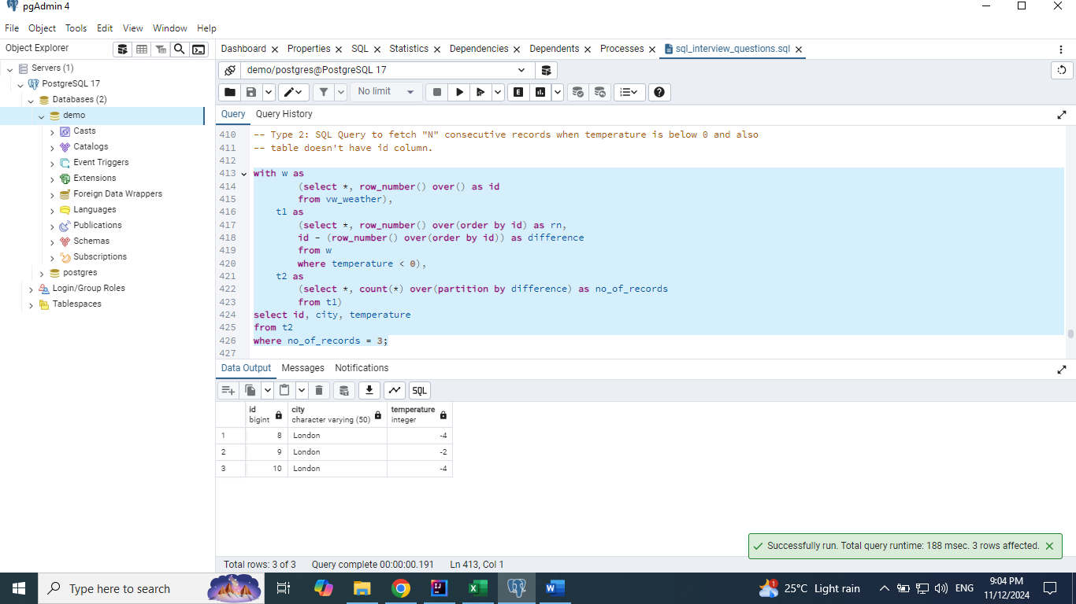

## Type 3: Fetch the records from table where there are orders for 3 consecutive days

**select *, row_number() over(order by order_id) as rn**

**from orders;**

**with t1 as**

**(select *, row_number() over(order by order_id) as rn ,**

**order_date - cast (row_number() over(order by order_id)as int) as difference**

**from orders),**

**t2 as**

**(select *, count(*) over(partition by difference) as no_of_records**

**from t1)**

**select order_id, order_date**

**from t2**

**where no_of_records = 2;**

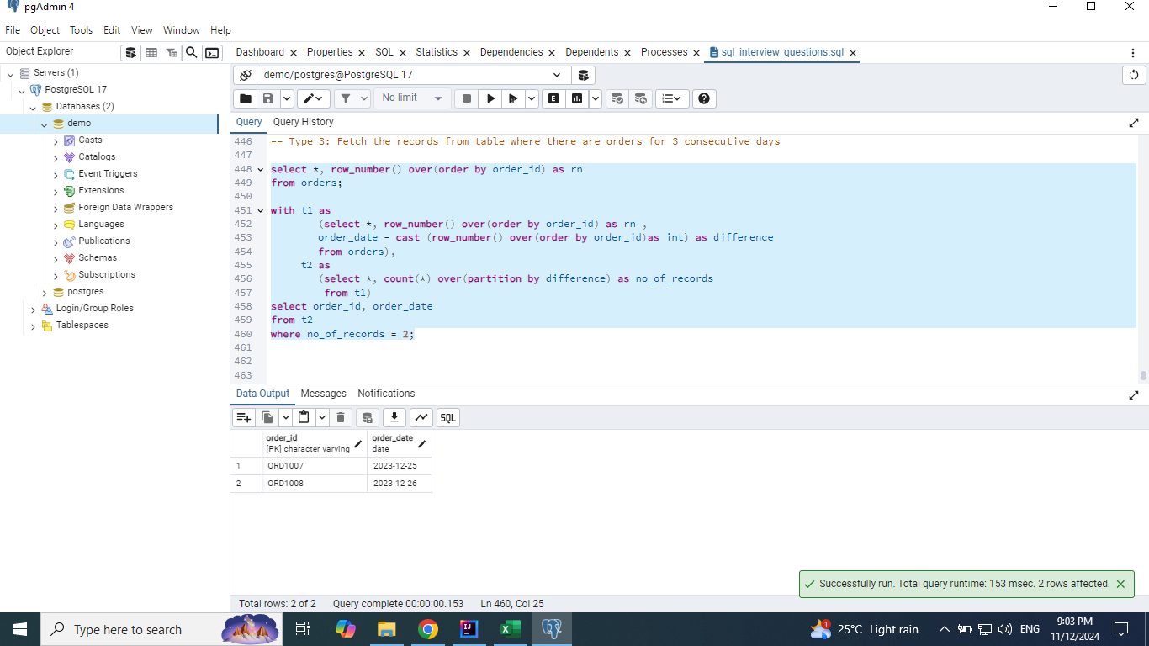

# Problem 8:

Imagine a Warehouse where items are stored in different batches as indicated in the Batch table. Customers can purchase multiple items in a single order as indicated in Orders table. Write an SQL query to determine items for each order are taken from which Batch. Assume that items are sequentially taken from each Batch starting from the first batch.

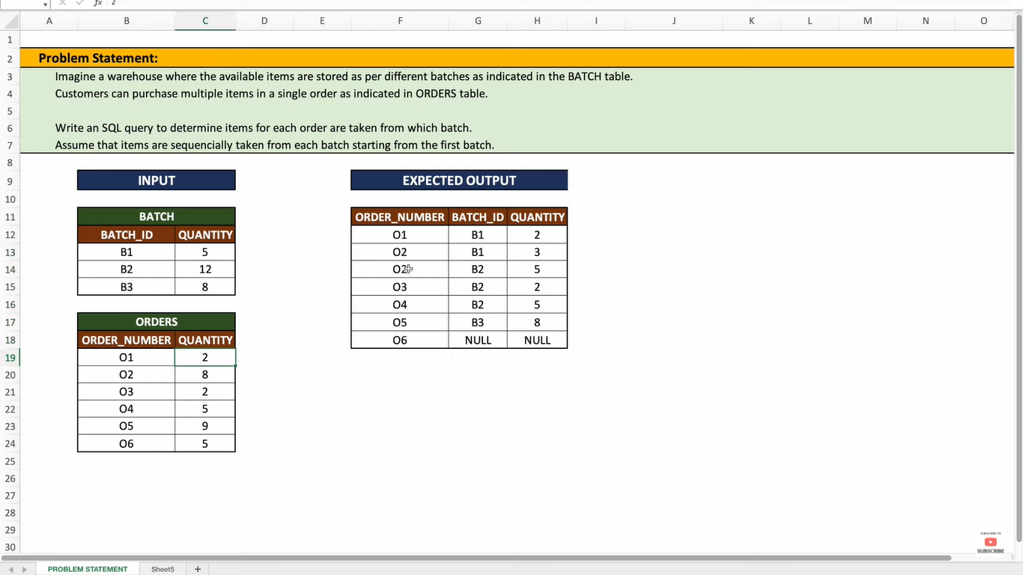

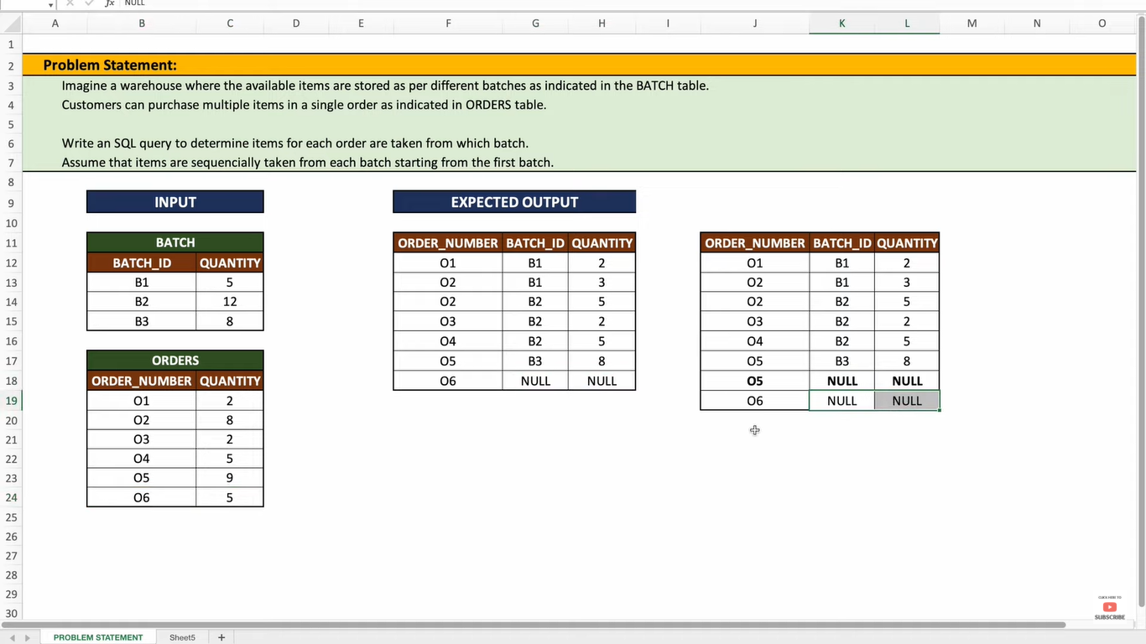

## Query Explanation:

This query aims to allocate items from **batches** to **orders**, ensuring that items are taken sequentially from batches starting with the first batch. Here’s a step-by-step explanation of how the query works

**Understanding the Data**

batch Table: Contains batch_id and quantity (number of items available in each batch).

orders Table: Contains order_number and quantity (number of items ordered in each order).

The goal is to match the required quantity for each order by sequentially drawing from the batches until the order is fulfilled.

## Query Breakdown:

**a. batch_split Recursive CTE**

Purpose: Expands the batch table into rows where each row represents a single item from the batch.

**Logic:**

The first query selects the first item for each batch (quantity = 1).

The recursive part generates additional rows for each item in the batch until the total batch quantity is covered.

**Output: A row for every item in the batches.**

**b. batch_cte**

Purpose: Adds a sequential numbering (row_number) to the expanded rows of the batch_split CTE.

Logic: Orders batches by batch_id and assigns a unique row_number to each item across all batches.

**c. orders_split Recursive CTE**

Purpose: Similar to batch_split, this expands the orders table into rows representing individual items ordered.

**Logic:**

The first query selects the first item for each order (quantity = 1).

The recursive part generates additional rows for each item in the order until the total order quantity is covered.

**Output: A row for every item in the orders.**

**d. order_cte**

Purpose: Adds a sequential numbering (row_number) to the expanded rows of the orders_split CTE.

**Logic: Orders by order_number and assigns a unique row_number to each item across all orders.**

**e. Joining batch_cte and order_cte**

Purpose: Matches items in batch_cte (items in batches) with items in order_cte (items ordered) using the row_number (rn).

**Logic:**

Join on rn to allocate items sequentially from batches to orders.

Use LEFT JOIN to ensure all orders are included, even if they cannot be fully fulfilled.

**f. Aggregating and Formatting the Result**

**Purpose: Aggregate the allocated items for each (order_number, batch_id) pair.**

**Logic:**

Group by order_number and batch_id.

Sum up the quantities for each group.

Order: Orders results by order_number and batch_id.

O1, O2, O3, O4: Fully fulfilled using available batches.

O5: Partially fulfilled using batch B3 but ran out of items for complete fulfillment.

O6: Could not be fulfilled due to lack of items in all batches.

**Expanding the table values**

with recursive batch_split as

(select batch_id, 1 as quantity from batch

union all

select b.batch_id, (cte.quantity+1) as quantity

from batch_split cte

join batch b

on b.batch_id = cte.batch_id

and b.quantity > cte.quantity)

select batch_id, 1 as quantity

from batch_split;

with recursive orders_split as

(select order_number, 1 as quantity from bat_orders

union all

select b.order_number, (cte.quantity+1) as quantity

from orders_split cte

join bat_orders b

on b.order_number = cte.order_number

and b.quantity > cte.quantity)

select order_number, 1 as quantity

from orders_split;

**Adding the row numbers**

select *, row_number() over(order by batch_id) as rn

from

(with recursive batch_split as

(select batch_id, 1 as quantity from batch

union all

select b.batch_id, (cte.quantity+1) as quantity

from batch_split cte

join batch b

on b.batch_id = cte.batch_id

and b.quantity > cte.quantity)

select batch_id, 1 as quantity

from batch_split) x;

select *, row_number() over(order by order_number) as rn

from

(with recursive orders_split as

(select order_number, 1 as quantity from bat_orders

union all

select b.order_number, (cte.quantity+1) as quantity

from orders_split cte

join bat_orders b

on b.order_number = cte.order_number

and b.quantity > cte.quantity)

select order_number, 1 as quantity

from orders_split) x;

**Final Query to join the tables**

**with batch_cte as**

**(select *, row_number() over(order by batch_id) as rn**

**from**

**(with recursive batch_split as**

**(select batch_id, 1 as quantity from batch**

**union all**

**select b.batch_id, (cte.quantity+1) as quantity**

**from batch_split cte**

**join batch b**

**on b.batch_id = cte.batch_id**

**and b.quantity > cte.quantity)**

**select batch_id, 1 as quantity**

**from batch_split) x),**

**order_cte as**

**(select *, row_number() over(order by order_number) as rn**

**from**

**(with recursive orders_split as**

**(select order_number, 1 as quantity from bat_orders**

**union all**

**select b.order_number, (cte.quantity+1) as quantity**

**from orders_split cte**

**join bat_orders b**

**on b.order_number = cte.order_number**

**and b.quantity > cte.quantity)**

**select order_number, 1 as quantity**

**from orders_split) x)**

**select o.order_number, b.batch_id, sum(b.quantity) as quantity**

**from order_cte o**

**left join batch_cte b on b.rn = o.rn**

**group by o.order_number, b.batch_id**

**order by o.order_number, b.batch_id;**

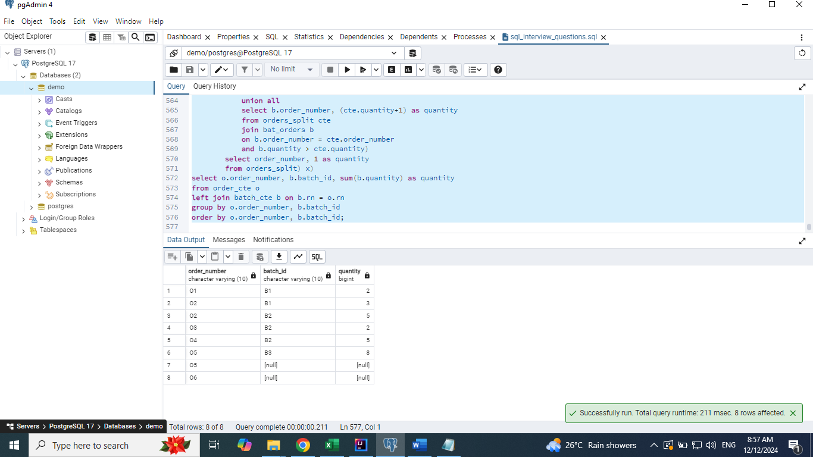

# Problem 9:

Write a SQL query to find the family members

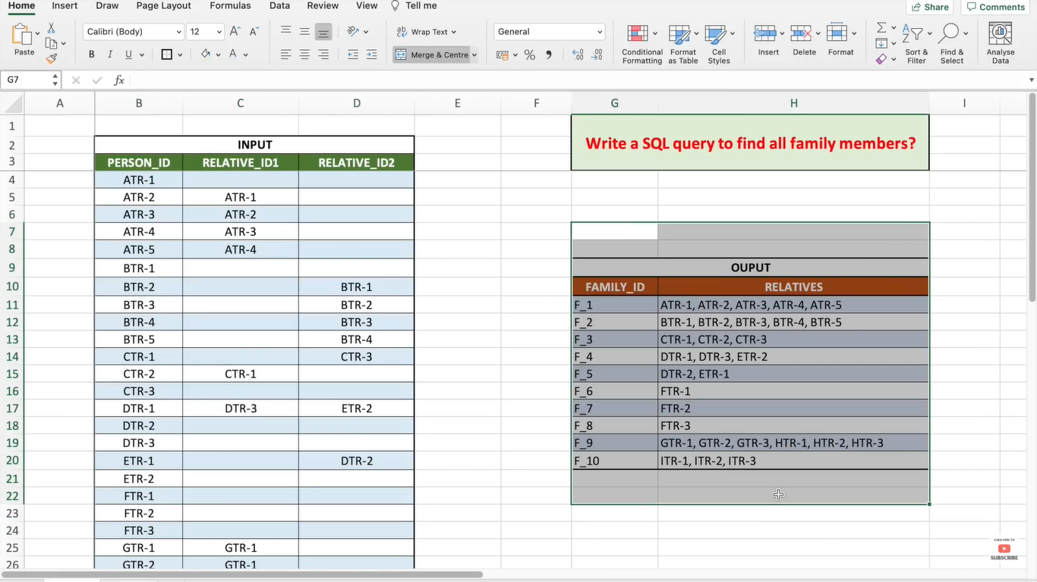

## Query Explanation:

This SQL query uses a recursive common table expression (CTE) to group related family members based on their relationships.

## Query Breakdown:

**Step 1: Define the base relationships (base_query)**

The base_query CTE extracts the basic relationships from the family_members table:

relative_id1 and relative_id2 are treated as relatives.

The fam_grp column groups members by the first 3 characters of person_id.

base_query as

(select relative_id1 as relatives, substring(person_id, 1, 3) as fam_grp from family_members

where relative_id1 is not null

union

select relative_id2 as relatives, substring(person_id, 1, 3) as fam_grp from family_members

where relative_id2 is not null

order by 1)

**Step 2: Define the recursive relationships (related_fam_members)**

The related_fam_members CTE starts with base_query and recursively joins to find transitive relationships:

Each iteration identifies new members connected via relative_id1 or relative_id2.

with recursive related_fam_members as

(select * from base_query

union

select fam.person_id, r.fam_grp

from related_fam_members r

join family_members fam

on fam.relative_id1 = r.relatives

or fam.relative_id2 = r.relatives)

This ensures that all family members directly or indirectly related are grouped together.

**Step 3: Identify individuals with no relatives (no_relatives)**

The no_relatives CTE identifies person_id values that:

Have no relative_id1 or relative_id2.

Are not part of the base_query.

no_relatives as

(select person_id from

family_members fam

where relative_id1 is null and relative_id2 is null

and person_id not in (select relatives from base_query))

**Step 4: Group relatives into families and assign IDs**

In the final query:

related_fam_members aggregates all related members into a single group using STRING_AGG().

no_relatives are included as individual families.

Each group is assigned a family_id using ROW_NUMBER().

select concat('F_', row_number() over(order by relatives)) as family_id,

relatives from

(select distinct string_agg(relatives, ', ' order by relatives) as relatives

from related_fam_members

group by fam_grp

union

select * from no_relatives) x;

**Grouping all the relatives together**

select relative_id1 as relatives from family_members

where relative_id1 is not null

union

select relative_id2 as relatives from family_members

where relative_id2 is not null

order by 1;

**Adding relatives into the family**

select relative_id1 as relatives, substring(person_id, 1, 3) as fam_grp from family_members

where relative_id1 is not null

union

select relative_id2 as relatives, substring(person_id, 1, 3) as fam_grp from family_members

where relative_id2 is not null

order by 1;

**Final Query**

**with recursive related_fam_members as**

**(select * from base_query**

**union**

**select fam.person_id, r.fam_grp**

**from related_fam_members r**

**join family_members fam**

**on fam.relative_id1 = r.relatives**

**or fam.relative_id2 = r.relatives),**

**base_query as**

**(select relative_id1 as relatives, substring(person_id, 1, 3) as fam_grp from family_members**

**where relative_id1 is not null**

**union**

**select relative_id2 as relatives, substring(person_id, 1, 3) as fam_grp from family_members**

**where relative_id2 is not null**

**order by 1),**

**no_relatives as**

**(select person_id from**

**family_members fam**

**where relative_id1 is null and relative_id2 is null**

**and person_id not in (select relatives from base_query))**

**select concat('F_', row_number() over(order by relatives)) as family_id,**

**relatives from**

**(select distinct String_agg(relatives, ', ' order by relatives) as relatives**

**from related_fam_members**

**group by fam_grp**

**union**

**select * from no_relatives) x;**

# Problem 10:

Julia conducted a days of learning SQL contest. The start date of the contest was March 01, 2016 and the end date was March 15, 2016. Write a query to print total number of unique hackers who made at least submission each day (starting on the first day of the contest), and find the hacker_id and name of the hacker who made maximum number of submissions each day. If more than one such hacker has a maximum number of submissions, print the lowest hacker_id. The query should print this information for each day of the contest, sorted by the date.

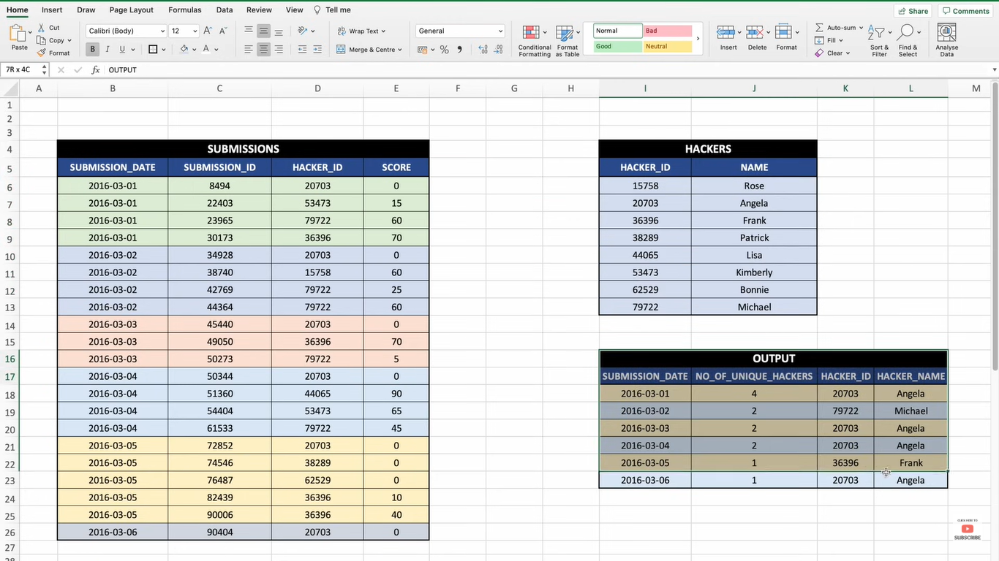

## Query Explanation:

The query provided is designed to solve a SQL challenge where we analyze data about a contest conducted over multiple days.

## Query Breakdown:

**Step 1: Recursive Common Table Expression (CTE)**

**cte**

Purpose: To determine all unique hackers who made submissions each day, starting from the first day of the contest.

**Logic:**

Initially selects the distinct submission_date and hacker_id for the first day (min(submission_date)).

Recursively joins the cte with the submissions table to identify hackers who made submissions on subsequent days. It ensures that each recursive step considers hackers from the previous days and selects submissions made on the next day (submission_date > cte.submission_date).

**Step 2: Count Unique Hackers Per Day**

**unique_hackers**

Purpose: To count the total number of unique hackers who made submissions on each day.

**Logic:**

Groups the data from cte by submission_date.

Uses COUNT(1) to calculate the total number of unique hackers for each day.

**Step 3: Count Submissions Per Hacker Per Day**

**submission_count**

Purpose: To count the number of submissions made by each hacker on each day.

**Logic:**

Groups data by submission_date and hacker_id.

Calculates the count of submissions using COUNT(1).

**Step 4: Find the Maximum Submissions Per Day**

**max_submission**

Purpose: To determine the maximum number of submissions made by a hacker for each day.

**Logic:**

Groups the submission_count data by submission_date.

Uses MAX(no_of_submission) to find the highest number of submissions for each day.

**Step 5: Identify Hacker(s) with Maximum Submissions**

**final_hackers**

Purpose: To identify the hacker with the maximum number of submissions for each day. If there is a tie, the hacker with the lowest hacker_id is selected.

**Logic:**

Joins max_submission and submission_count on submission_date and max_submission to get the list of hackers who made the maximum number of submissions.

Uses MIN(hacker_id) to resolve ties by selecting the hacker with the smallest ID.

**Step 6: Combine Results**

**Final SELECT**

Purpose: To consolidate and display the results for each day, including:

The date of the submissions (submission_date).

The total number of unique hackers who submitted (no_of_hackers).

The hacker_id and name of the hacker with the maximum submissions for that day.

**Logic:**

Joins unique_hackers with final_hackers and the hackers table (to get hacker names).

Orders the results by submission_date.

**Base query**

select distinct submission_date, hacker_id

from submissions

where submission_date = (select min(submission_date) from submissions);

**Print total number of unique hackers who made at least submission each day (starting on the first day of the contest)**

with recursive cte as

(select distinct submission_date, hacker_id

from submissions

where submission_date = (select min(submission_date) from submissions)

union

select s.submission_date, s.hacker_id

from submissions s

join cte on cte.hacker_id = s.hacker_id

where s.submission_date = (select min(submission_date) from submissions

where submission_date > cte.submission_date)),

unique_hackers as

(select submission_date, count(1) as no_of_hackers

from cte

group by submission_date);

**Find the hacker_id and name of the hacker who made maximum number of submissions each day. If more than one such hacker has a maximum number of submissions, print the lowest hacker_id.**

with submission_count as

(select submission_date, hacker_id, count(1) as no_of_submission

from submissions

group by submission_date, hacker_id

order by 1),

max_submission as

(select submission_date, max(no_of_submission) as max_submission

from submission_count

group by submission_date)

select c.submission_date, min(c.hacker_id) as hacker_id

from max_submission m

join submission_count c

on c.submission_date = m.submission_date

and c.no_of_submission = m.max_submission

group by c.submission_date;

**Final query**

**with recursive cte as**

**(select distinct submission_date, hacker_id**

**from submissions**

**where submission_date = (select min(submission_date) from submissions)**

**union**

**select s.submission_date, s.hacker_id**

**from submissions s**

**join cte on cte.hacker_id = s.hacker_id**

**where s.submission_date = (select min(submission_date) from submissions**

**where submission_date > cte.submission_date)),**

**unique_hackers as**

**(select submission_date, count(1) as no_of_hackers**

**from cte**

**group by submission_date),**

**submission_count as**

**(select submission_date, hacker_id, count(1) as no_of_submission**

**from submissions**

**group by submission_date, hacker_id**

**order by 1),**

**max_submission as**

**(select submission_date, max(no_of_submission) as max_submission**

**from submission_count**

**group by submission_date),**

**final_hackers as**

**(select c.submission_date, min(c.hacker_id) as hacker_id**

**from max_submission m**

**join submission_count c**

**on c.submission_date = m.submission_date**

**and c.no_of_submission = m.max_submission**

**group by c.submission_date)**

**select uh.submission_date, uh.no_of_hackers, fh.hacker_id, hk.name as hacker_name**

**from unique_hackers uh**

**join final_hackers fh**

**on fh.submission_date = uh.submission_date**

**join hackers hk on hk.hacker_id = fh.hacker_id**

**order by 1;**

